Our Sustainable Apparel Coalition Membership: Longstanding, Meaningful and Passionate
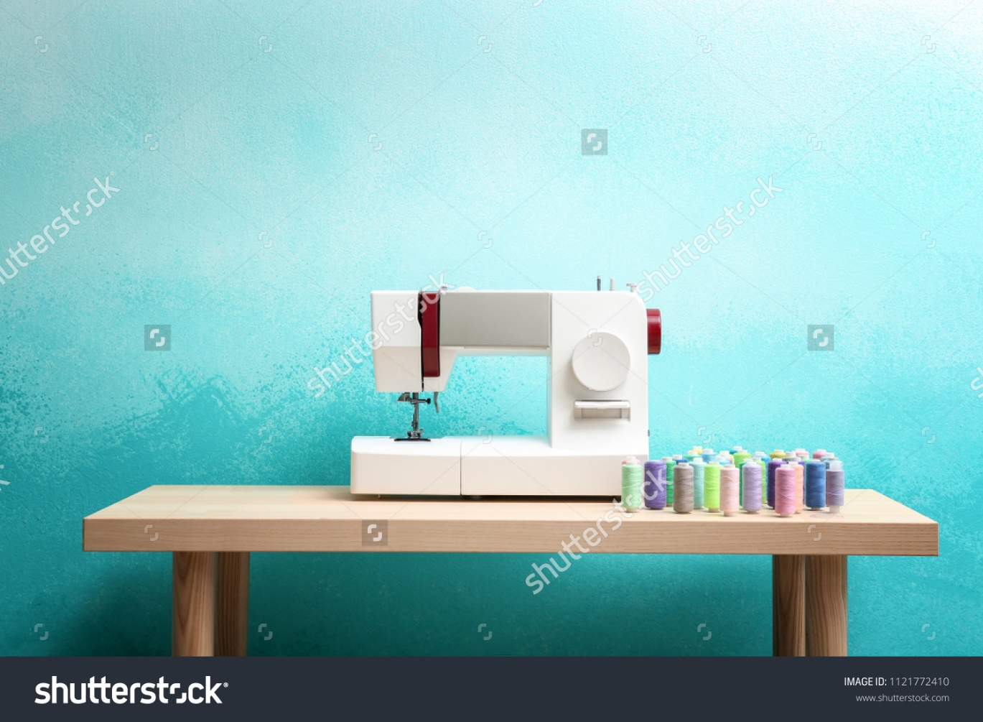
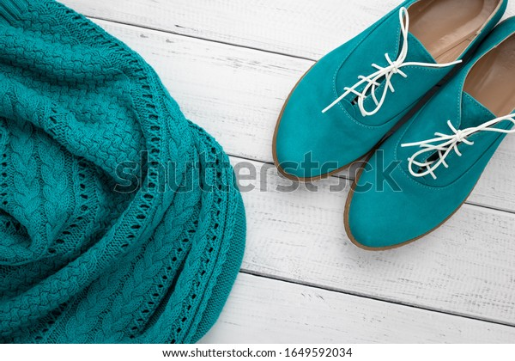

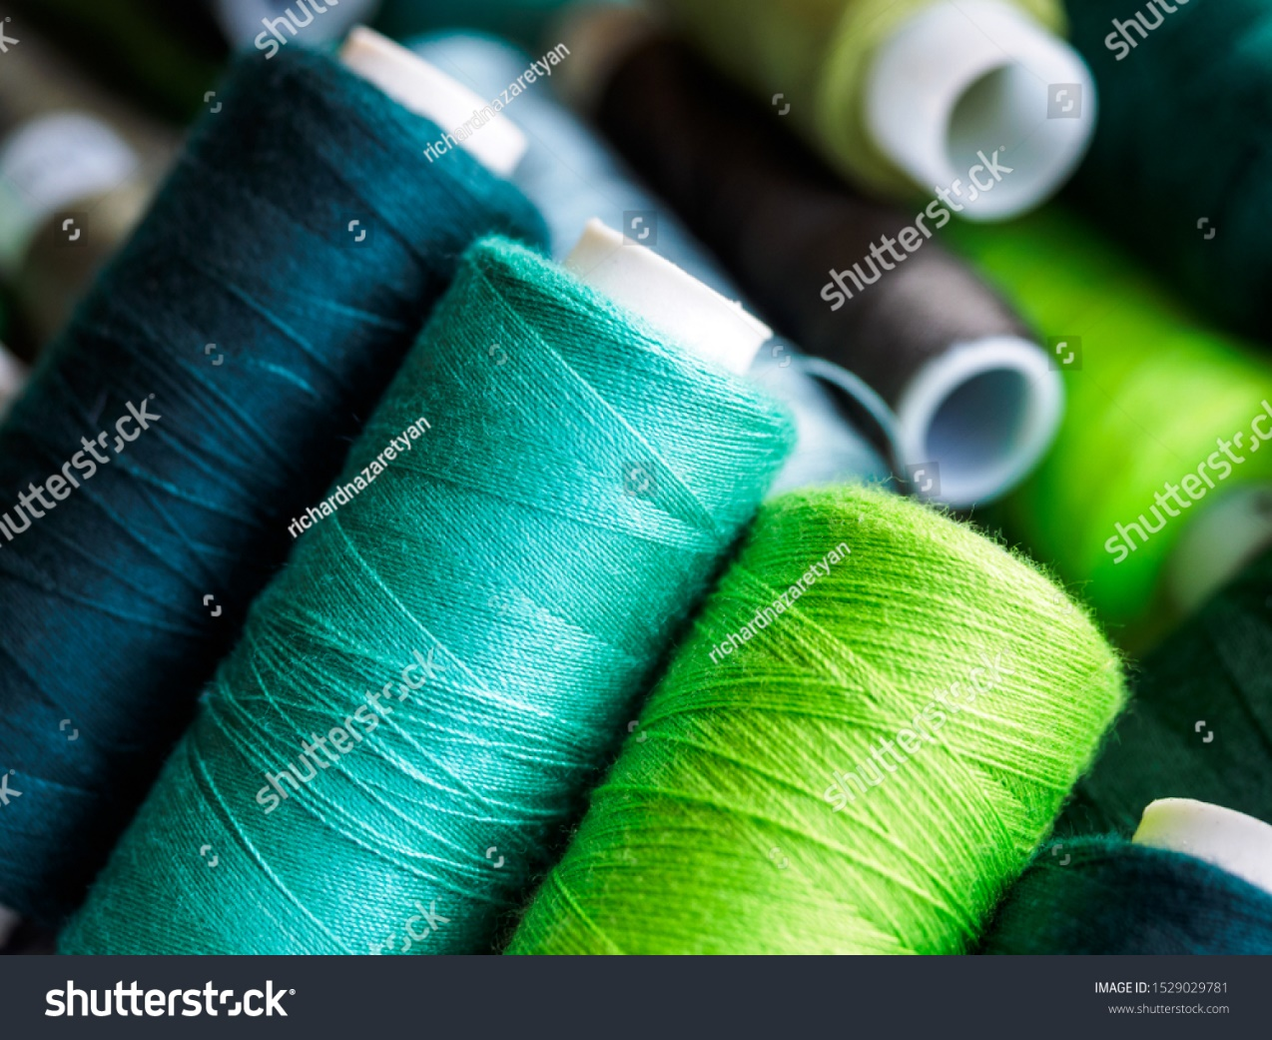

We are happy to announce that also in 2022 we are proud members and supporters of SAC! We are members at a leader level and therefore demonstrate industry leadership by driving impact.

As an associate SAC member, we can collaborate with the largest and most diverse industry network focused on creating transformative change. As SAC works on the reduction of environmental and social impacts of products around the world, we share the vision of “a global consumer goods industry that gives more than it takes – to the planet and its people.”

Here are some reasons for brands to join:
- Boost productivity
- Evaluate more meaningfully
- Reduce the assessment burden
- Grow business
- Develop knowledge
- Have equal say
- Deepen impact

Leadership & Sustainability and its longstanding commitment to SAC
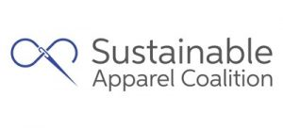
We are SAC members since 2016. With our membership in the Sustainable Apparel Coalition (SAC), we are globally connected with more than 250 brands, retailers and manufacturers. And are also connected to governments, non-profit environmental organizations and academic institutions in 36 different countries. All of them are increasingly committed to improving sustainability along the supply chain in the apparel, footwear, and textile industry.

SAC has created the Higg Index which is one of the leading assessment frameworks in the apparel, footwear and textile sector. At Leadership & Sustainability we share a long-standing commitment to SAC as our CEO Karin Ekberg has been involved with SAC since its very beginning and has co-led the creation of the Sustainable Apparel Coalition, among others in her role as the first Chairperson of the Board of Directors.

We are very pleased to be a part of SAC and we are looking forward to our continued dedicated participation in the industry-wide effort in sustainability. Therefore, we are committing to further developments and expansion of use of the Higg Index Tools in the industry. We will do our best to fulfil SAC’s expectations. Our goal is to make an impactful contribution towards responsible industry actions and to drive increased sustainability through meaningful collaborations across the textile and apparel industry.
Leadership & Sustainability is able to support you with the tools in Higg Index, for example:
- Brand and retail module (BRM)
- Facility environmental module (FEM)
- Facility social and labor module (FSLM/ SLCP)

Please reach out to us to learn more.

We want to help develop and empower Sustainability Leadership

If your organization is not currently a member of SAC and is interested in accessing the Higg Tools, you may inquire here.

Hashtags: Sustainability, Nachhaltigkeit, SAC, Higg Index, Leadership, Leadership & Sustainability, brand, retail, facility, environmental management, Umweltmanagement, FSLM, SLCP, Higg FEM, Higg BRM, Sustainable Apparel Coalition, etc.

